1.Domain class object Life Cycle:- The Domain class object can be in one of the following states:

A. Transient

b. Persistence

c. Detached.

d. Removed.

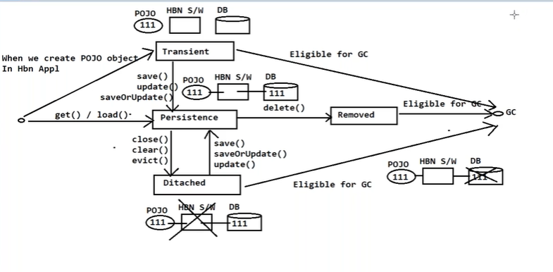

1. Transient :-When Domain class/Persistent class object is created in hibernate application, the Domain class object enters into Transient state.

If the Domain class object be in transient state for long time then It is eligible for Garbage collection.

1. Persistence:-If Domain class object state is stored in DB table as record **or**

save(-),update(-) or saveOrUpdate(-) method is invoked on Domain class object

**Or**

Hibernate application gets record from DB and stores into a Domain class object then it will leaves Transient state and enters into Persistence state.

1. **Ditached:-** When we close the hibernate session or we clear the hibernate session , domain class object will enters into ditached state.

If the Domain class object be in Ditached state for long time then It is eligible for Garbage collection.

1. **Removed:**- when hibernate application removes the record from DB table, the domain class object will enters into removed state. Once Domain class object enters into removed state it is eligible for garbage collection.